# **Sales Data Analysis Project**

1. **To find the total transactions by store type**

select storetype, sum(transactionamount) from SalesData

group by storetype;

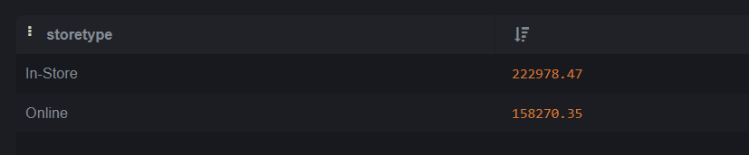

1. **To find out highest payment methods in both storetypes**

with cte as (

select storetype,paymentmethod,count(paymentmethod) as total_payment_method ,

dense_rank() over(partition by storetype order by count(paymentmethod) desc) rn

from SalesData

group by storetype,paymentmethod

)

select a.storetype,string_agg(a.paymentmethod,',') from (

select storetype ,paymentmethod,total_payment_method from cte where rn=1

) a

group by a.storetype;

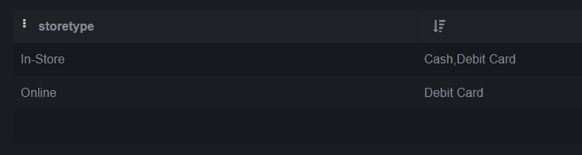

1. **Highest revenue generated in which city under storetype category**

with cte as (

select city,storetype,sum(transactionamount) as total,

dense_rank() over(partition by storetype order by sum(transactionamount) desc) rank_1

from SalesData

group by city,storetype

)

select city,storetype from cte where rank_1=1;



1. **Product with highest sale**

With cte as (

SELECT productname,sum(transactionamount) as total ,

rank() over (order by sum(transactionamount) desc) rank

from SalesData

group by productname

)

select productname from cte where rank=1;



1. **To find the AOV (Average order value)**

select (sum(transactionamount) /count(transactionamount)) as Average_order_value from SalesData

;

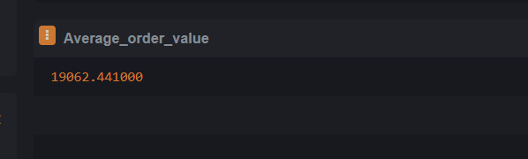

**Key Highlights: (Based on 20 records for sample)**

* Cash and debit were used as highest payment methods for both storetype.
* Lucknow and Jaipur were the cities with highest revenue with respective storetype
* Laptop was the highest sold product
* Average order value is 19062

*Note: The above analysis is based on 20 records as sample data. The SQL logic in this project is scalable to a large dataset as well.*